**Capstone Project – The Battle of Neighborhoods – Exploring Ottawa**

**Applied Data Science Capstone by IBM/Coursera**

**February 26, 2021**

**Introduction: Business Problem**

Humans are always looking to make the right choices, especially, when it comes to big future-defining decisions. Being an immigrant myself, I’ve spent sleepless nights and long days weighting in our family’s choice to move to Canada. Eventually, I’ve met many people who were “in the same boat” and it turned out that we share a lot of common expectations, needs and that similar factors impact our final choice. That is why I chose to explore downtown Ottawa, Canadian Capital as a destination of choice to a lot of immigrants that I know. Setting aside such obvious factors as bilingualism of the area, convenient geographical location (Ottawa is almost equally distant from Toronto, Quebec City and New York, just some 4 hours drive!), I wanted to take a closer look at its social and economical aspect. My target audience are Eastern European people making their final choices between Canadian cities and towns. These people are usually couples or young families coming from big cities, they like to go out for lunch with friends, are well educated and know what they want from life. Also, newcomers prefer to settle in downtown areas which provide good transportation and access to most jobs and enable them to get the best feel of history and culture. Hence, in this project we will be looking at downtown Ottawa City Hall area.

**Data**

We will use our data powers to generate several types of results. One of them is the housing trend. Are the Ottawa house purchase prices increasing or declining over the course of time? What about rent costs? This a very important question since shelter is a basic human need and we need to see if it’s worthwhile to buy or rent right now. COVID-19 has impacted many lodging trends worldwide, so let’s take a closer look at what would be the best option for the savings our newcomers would bring along to Canada. Also, we’ll use Foursquare to determine how many restaurants are in the area and what are the local places of interest. Also, we’ll look at schools since newcomers often choose to obtain Canadian certificate as an addition to their native degree or, in case if they have kids, we’ll need to make sure a variety of schools is available in the downtown district. We’ll come of with results that will help in deciding if Ottawa is an appropriate solution for people with background as described above.

Based on definition of our problem, factors that will influence our decision are:

* House price tendency for the past 20 years
* Rental costs for the past 4 years for 1-, 2- and 3-bedroom accommodations
* Number of restaurants in the area
* Number of places of interest in the area
* Number of schools in the area

Following data sources will be used to extract/generate the required information:

* <https://foursquare.com> API for lists and geographical location of schools, restaurants and entertainment venues in Ottawa city center, data will be displayed on the maps and in tables
* <https://www.agentinottawa.com> for accommodation purchase price tendencies for the past 20 years, data will be displayed on the plot
* <https://www.zumper.com> for accommodation rent costs dynamics since 2016, data will be displayed on the plot

**Neighbourhood Exploration**

First, let’s start with using Foursquare API to get geographical coordinates (latitude and longitude) of Ottawa; schools, restaurants and attractions within 3km city center radius:

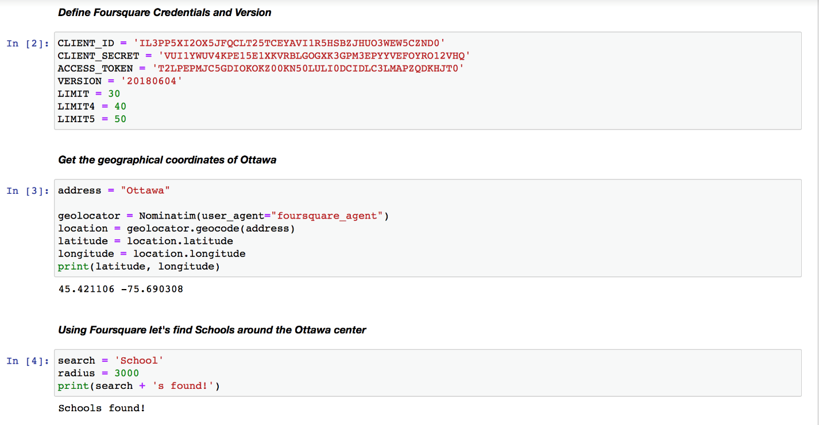

Creating URL link to school results. Retrieving the data from this link using GET function. Examining JSON results:

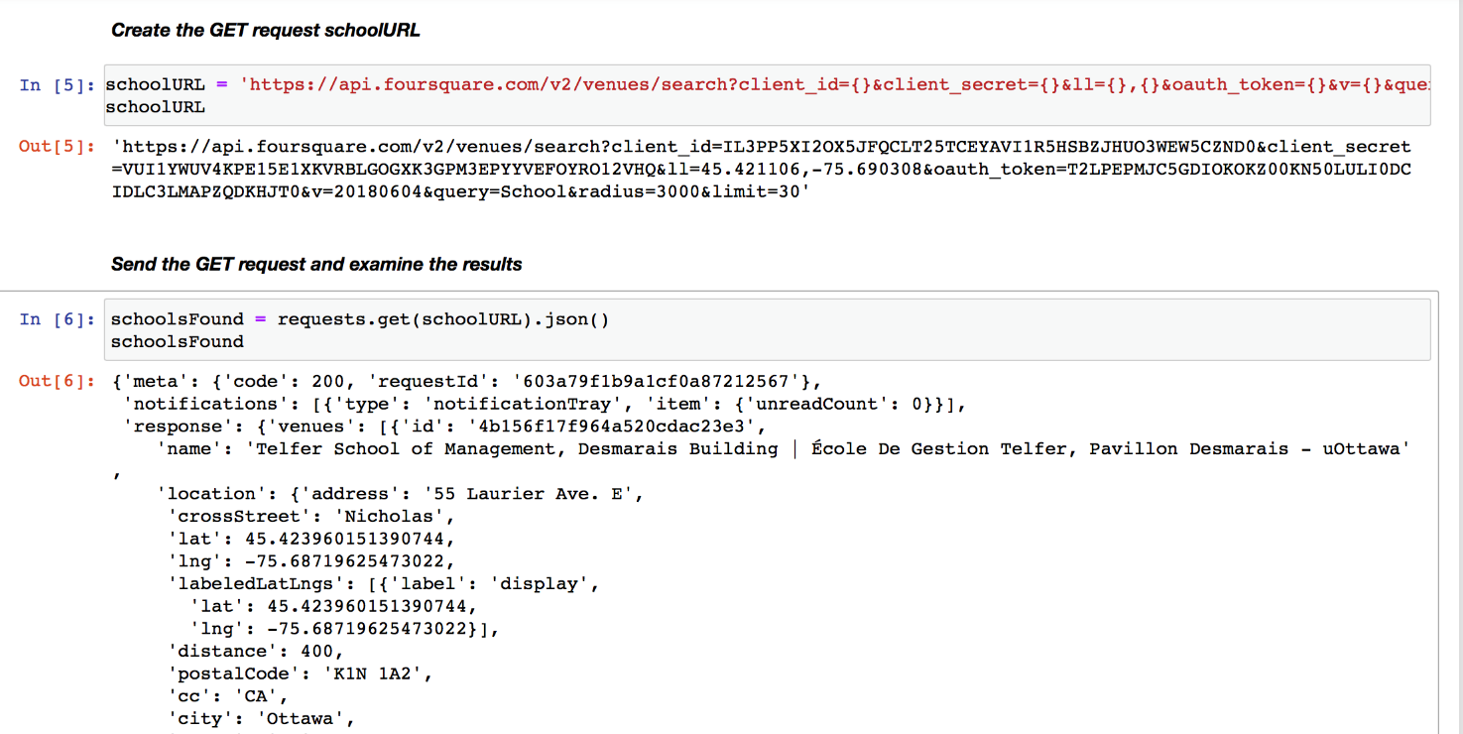

Next step is assigning relevant part of JSON to found schools and transforming it to dataframe:

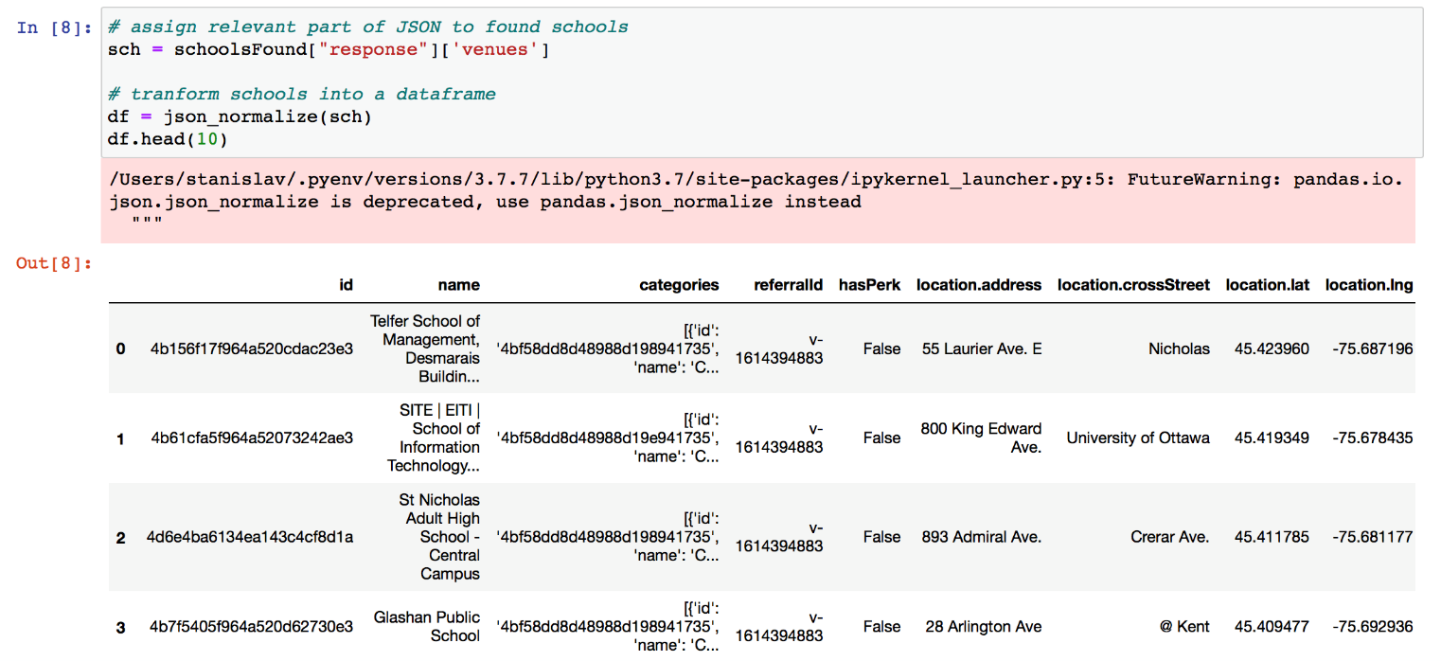

Cleaning our data, removing irrelevant information and columns for convenience. We’ll only keep the columns that include school name and anything that is associated with their locations. Creating a function that extracts the school category, then filtering the category for each row.

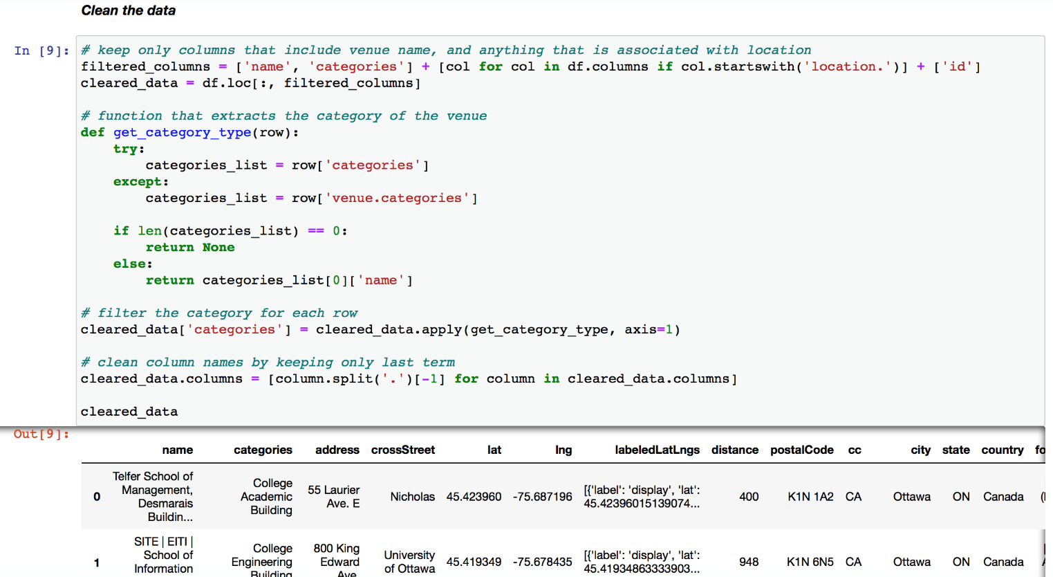

Taking a first glance at the list of schools in Ottawa (3km city center radius):

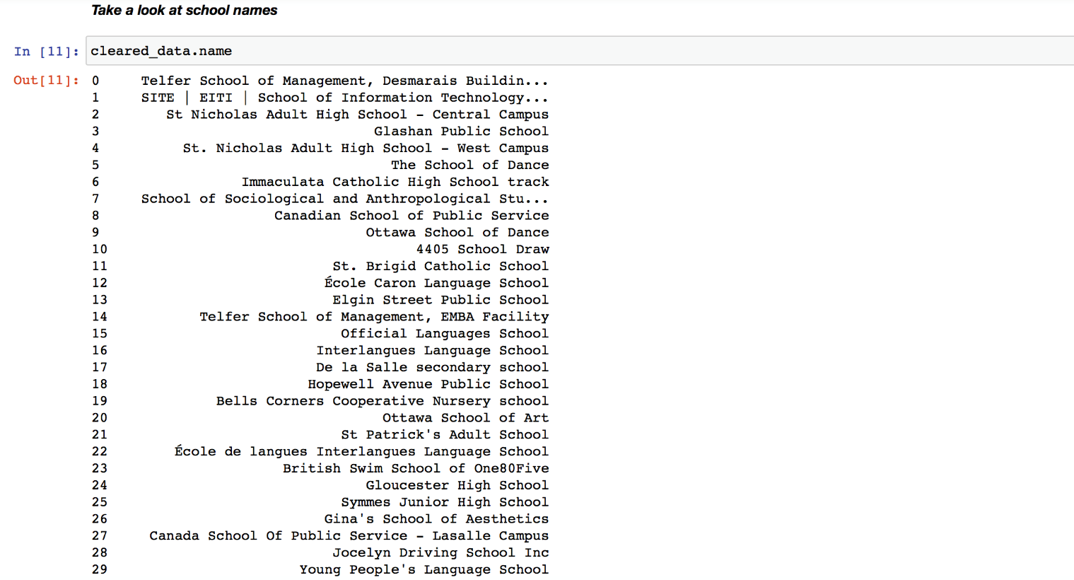

Data visualization: after data was cleaned and we have a list of schools, let’s display it on the map for better understanding of their location:

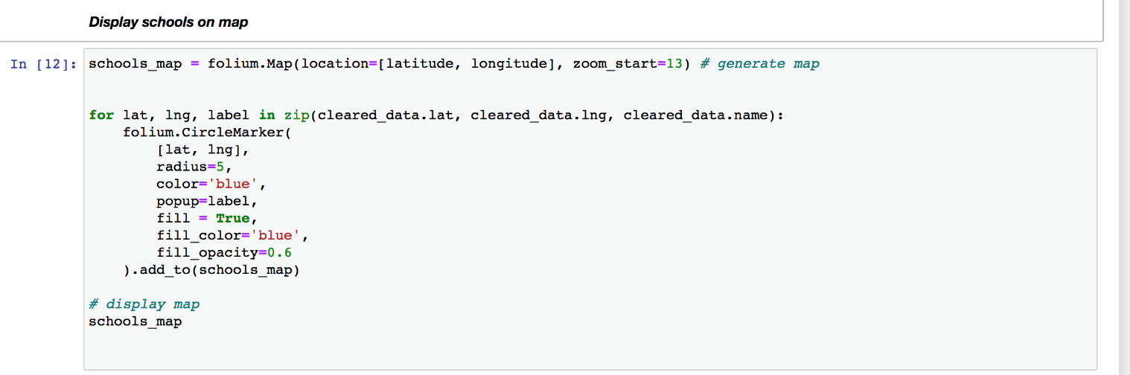

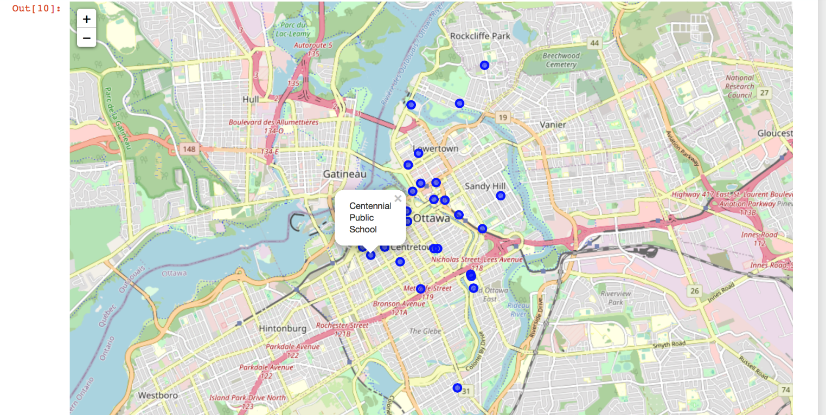

Next step is exploration of house purchase and rental prices. We’ll look at the average house cost in Ottawa for the last 20 years to get a better understanding if the city is attractive overall. Increasing tendencies would indicate that the city is growing and developing, people are moving in and demand is high (even despite the historical financial collapses, i.e. real estate market crash in 2008). Another important aspect to look at are the rental costs. What were the overall tendencies in rent costs, and did they change in 2020 due to COVID-19? This will help to make the eventual decision on feasibility of buying vs renting.

First, we’ll use Pandas to convert .csv file containing house purchase price data from <https://www.agentinottawa.com> to dataframe.

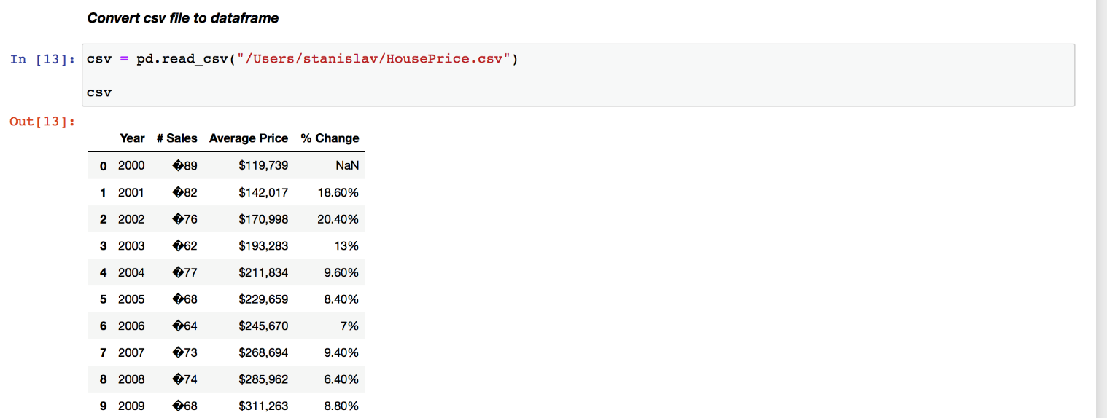

Cleaning data: dropping unnecessary columns and setting first column as Index. Also, removing dollar sign to make Price Column numeric and assign integer type:

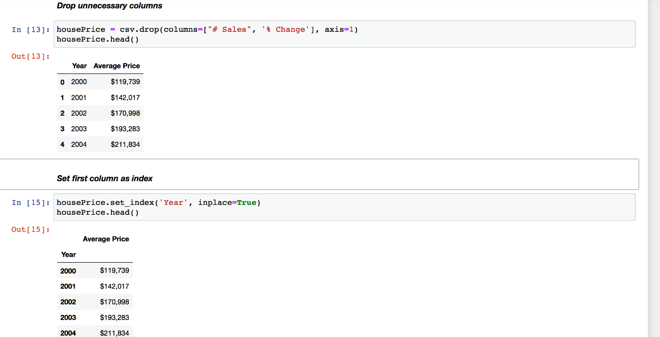

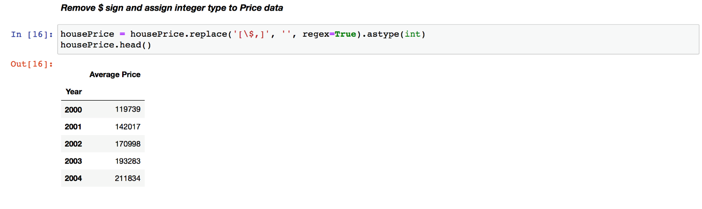

After data cleaning we can visualize data tendencies on the graph (bar kind):

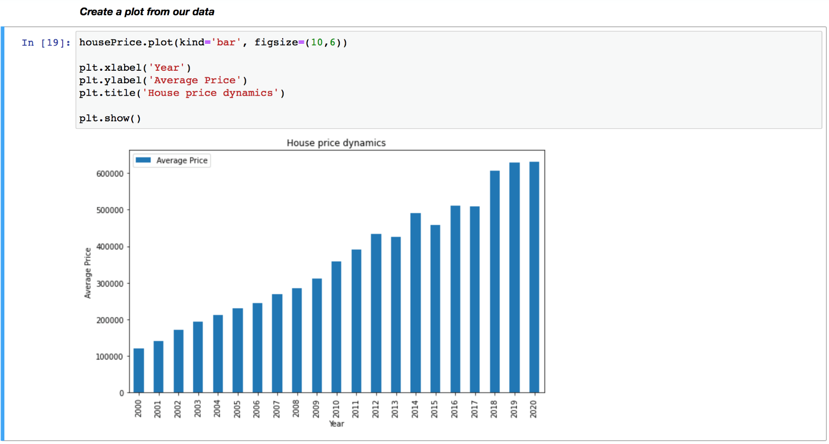

Now, repeating similar steps for rental costs data - using Pandas to convert .csv file from <https://www.zumper.com> to dataframe:

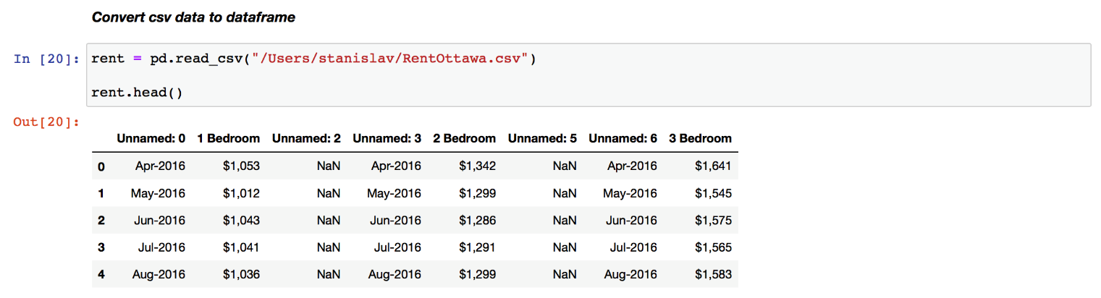

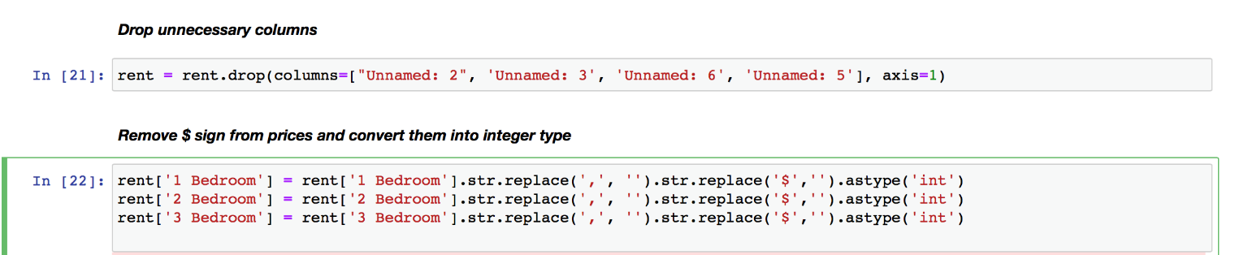

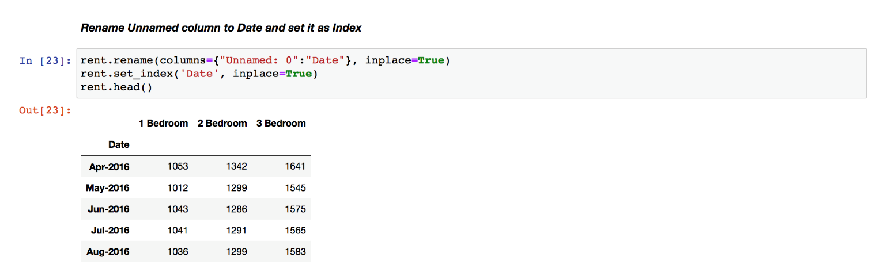

After cleaning data we can visualize the results on the graph (line kind):

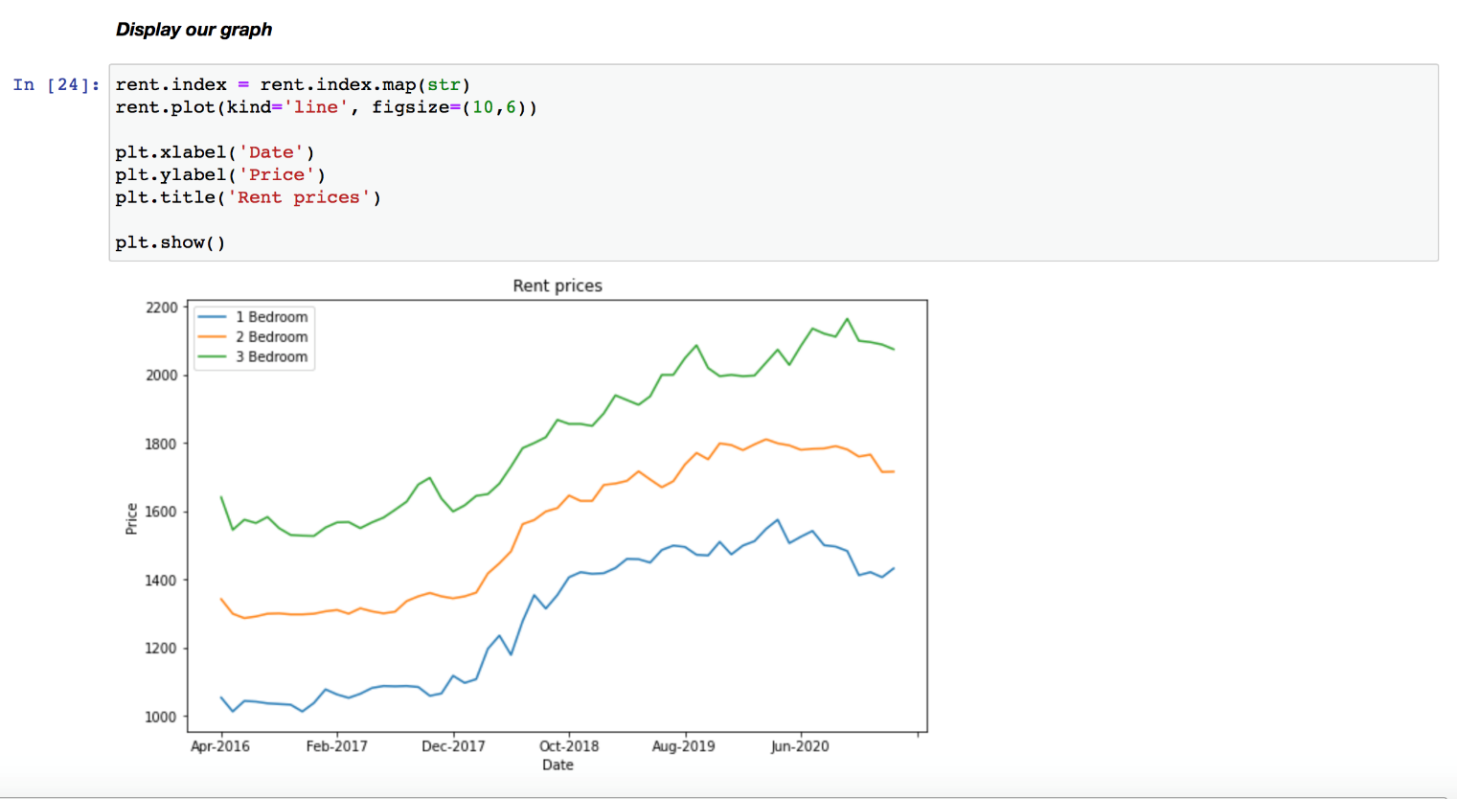

Next step is exploring entertainment options. Foursquare will be used once again, but this time with “explore” function (within 3km radius from city center). Creating URL link to venue exploration results. Retrieving the data from this link using GET function in JSON format and examining it:

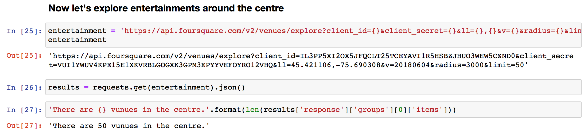

Generating dataframe. Cleaning our data, removing irrelevant information and columns for convenience. We’ll only keep the columns that include such things as venue name, category, address, etc.

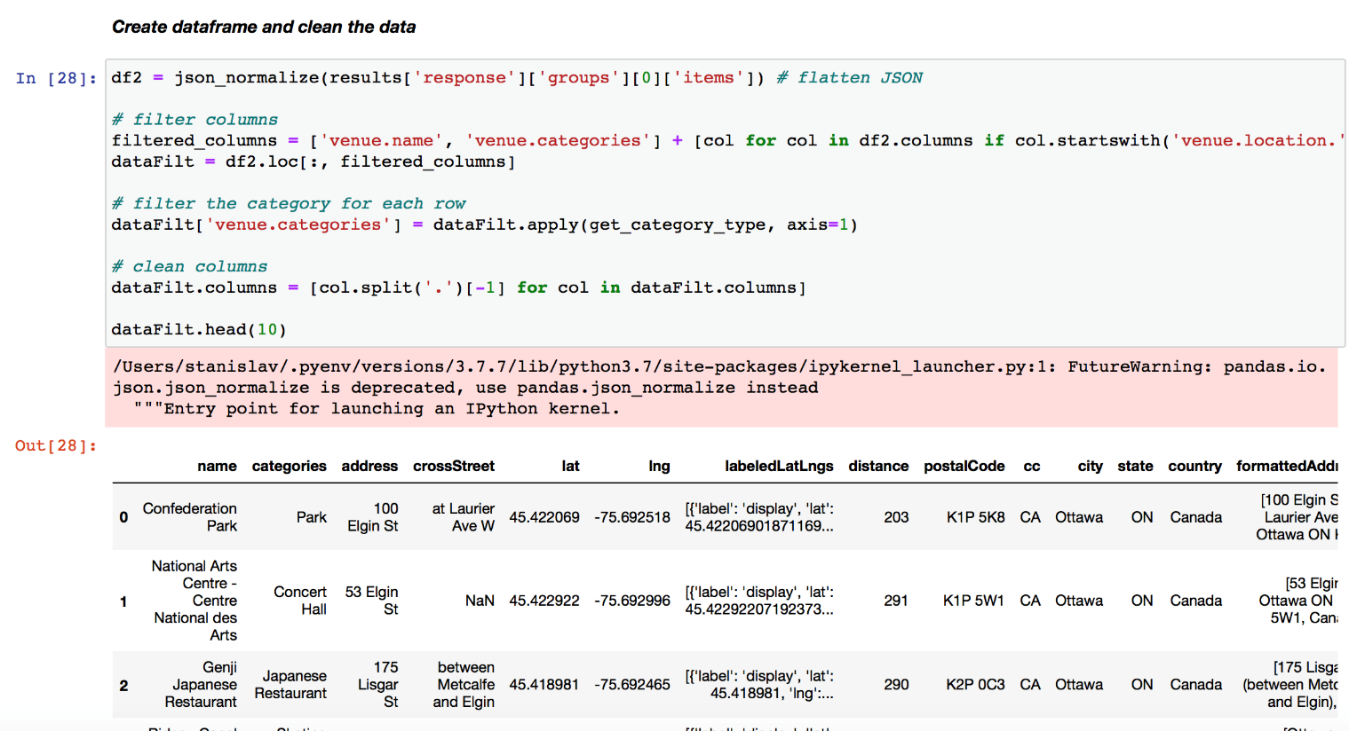

Let’s see found venues name list:

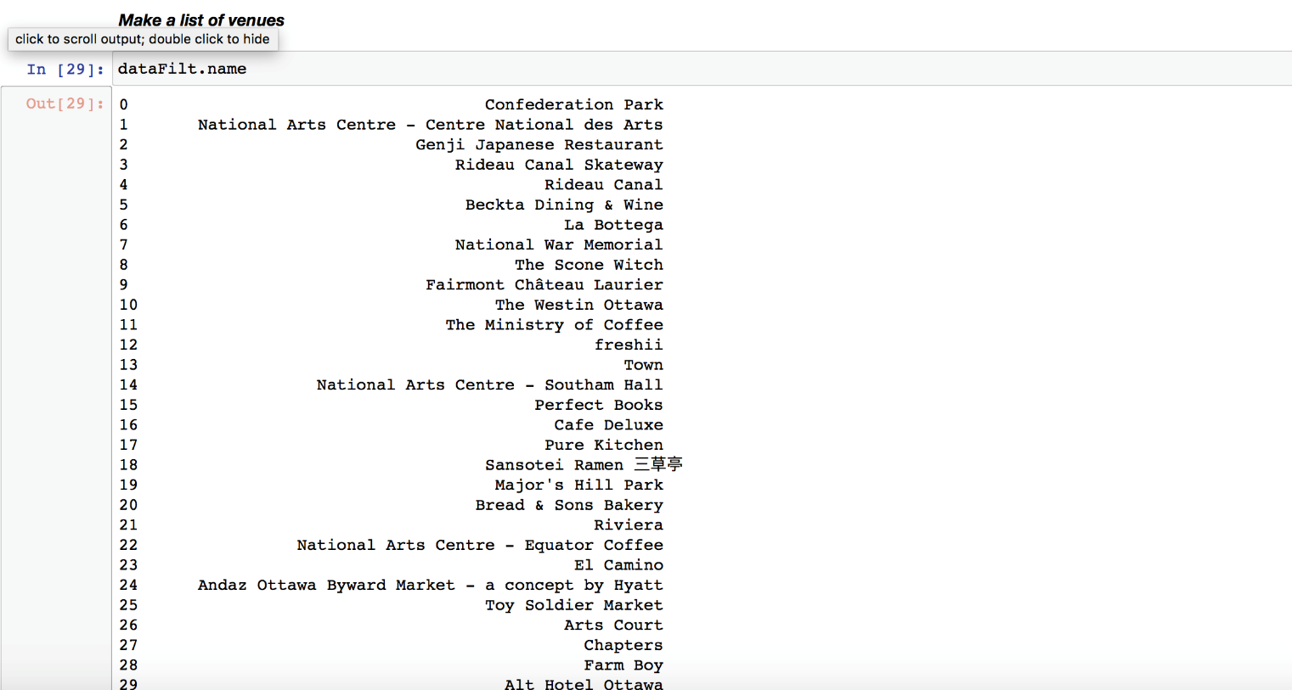

Visualising our results on the map. We’ll mark Ottawa City Hall as center in yellow dot, restaurants will be marked red and blue:

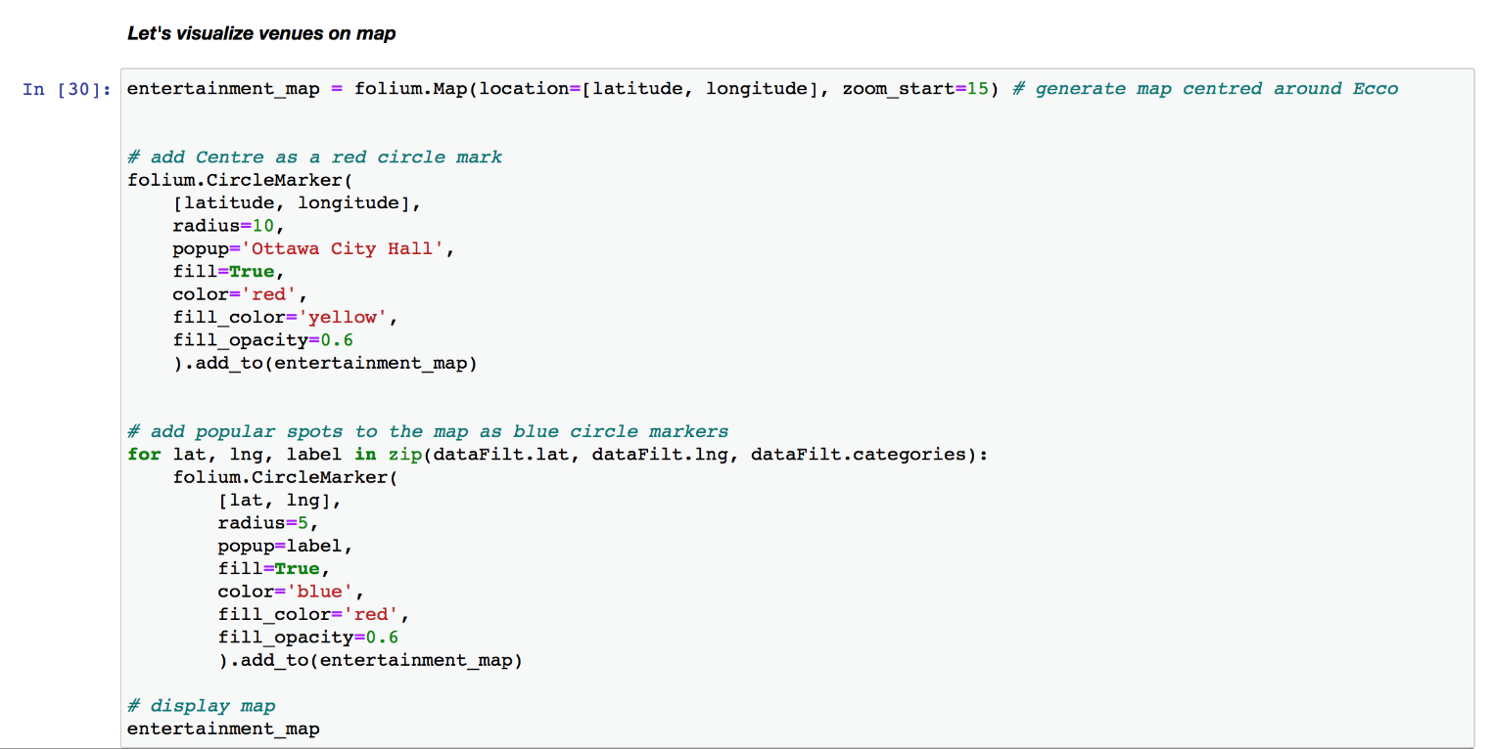

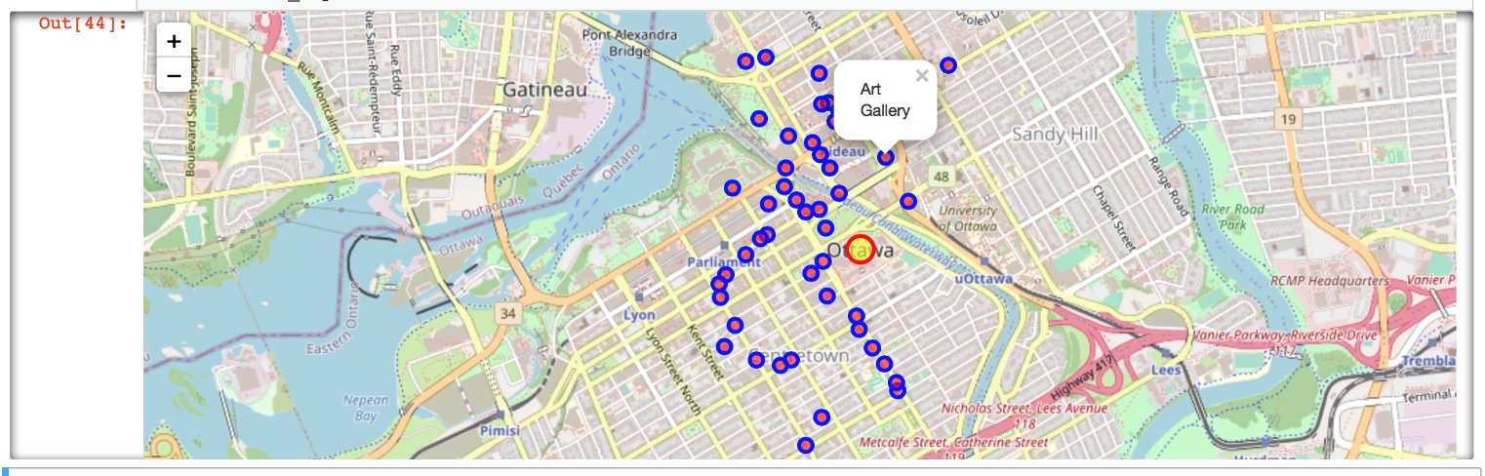

Applying similar approach as we did with schools, let’s find restaurants using Foursquare API, create URL, assign relevant part of JSON, and arrange data in dataframe:

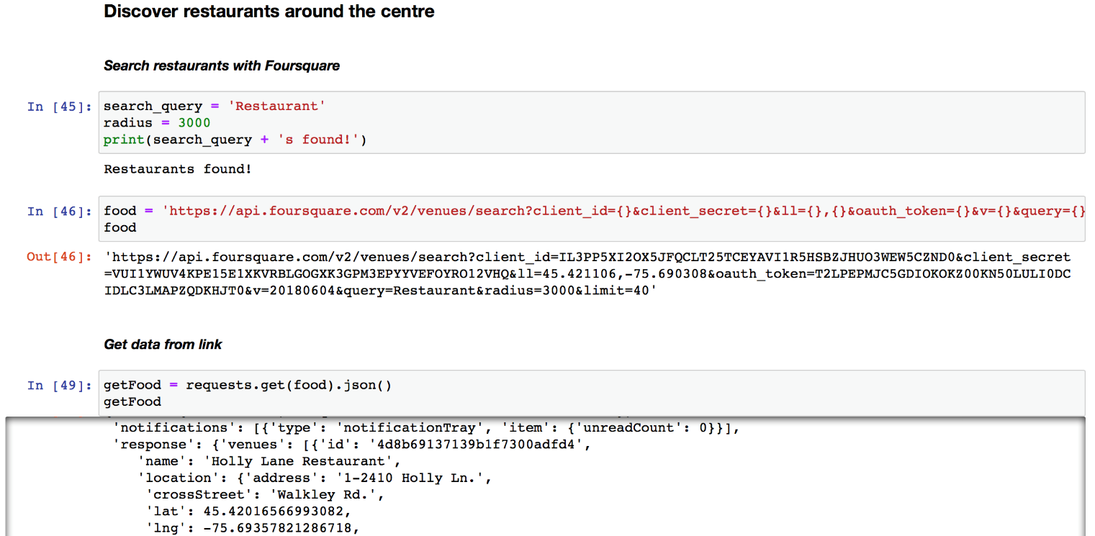

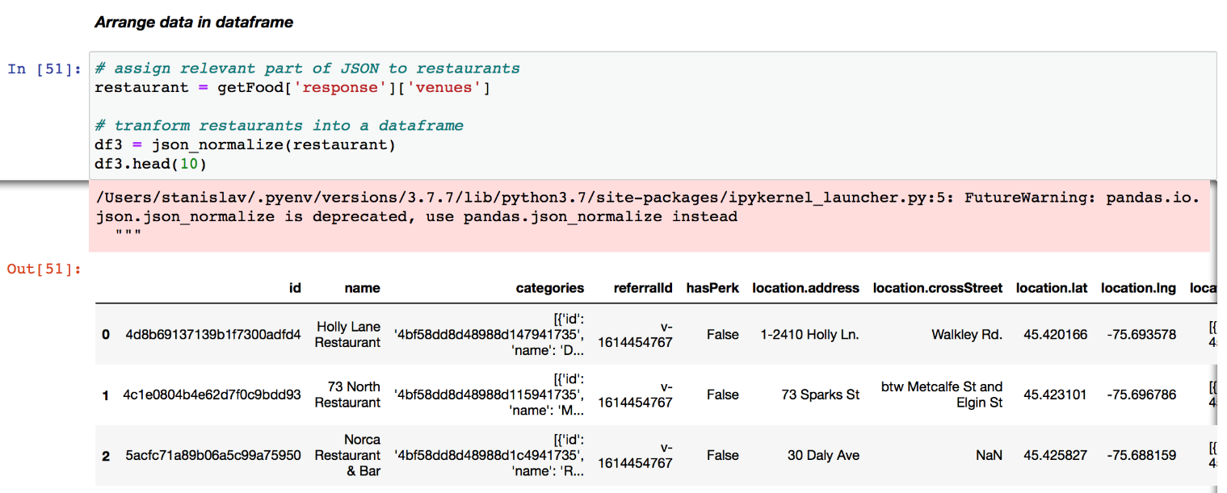

Cleaning data:

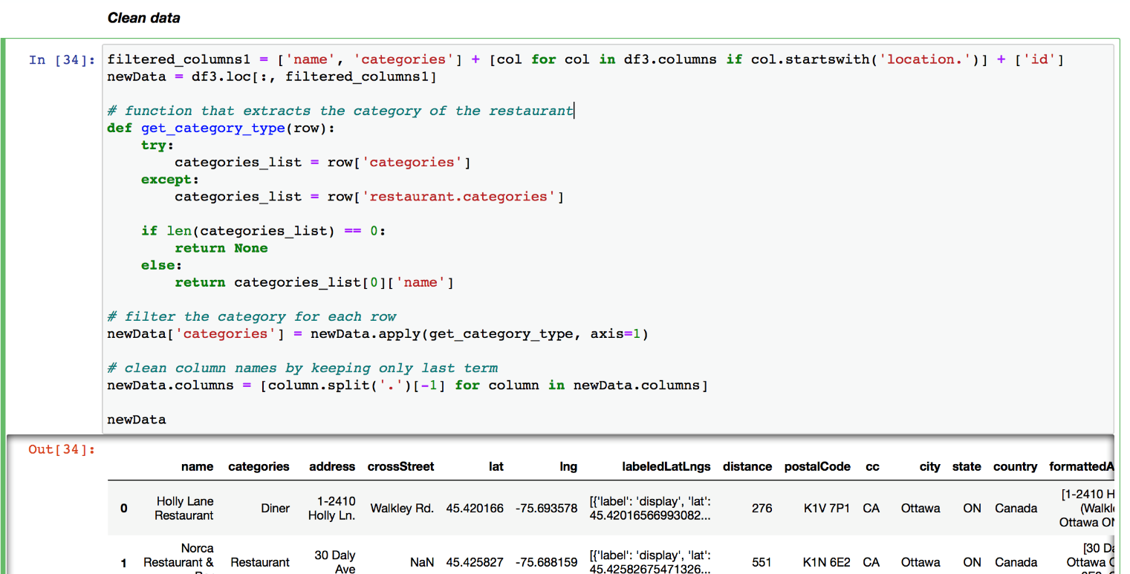

Ottawa has a unique location – territory across the river from the city center is not part of the Province of Ontario, but rather Province of Quebec. In our results we see that some of the restaurants meet the 3km criteria, however, they are located on the other bank of the river, hence in Quebec. We need to clean data again to remove “QC” rows from the “state” column:

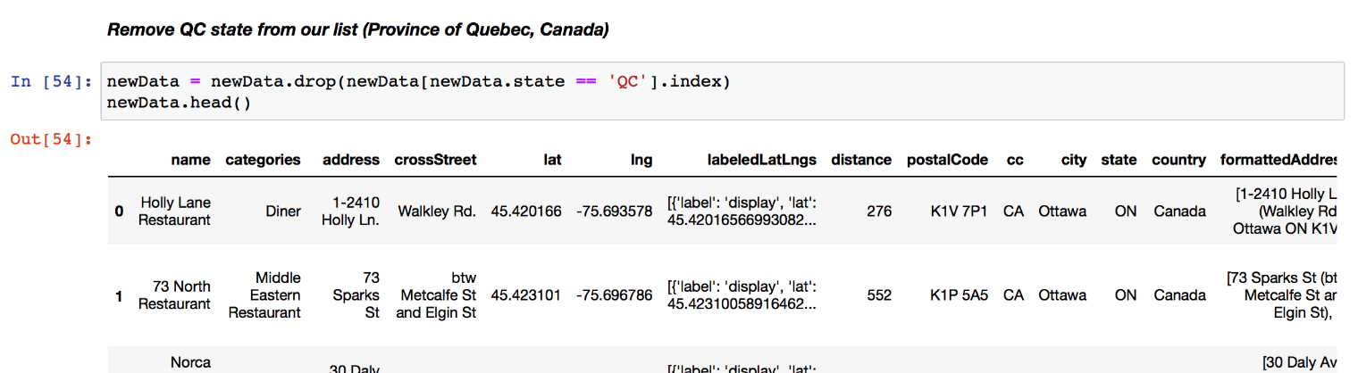

Let’s visualize data on the map:

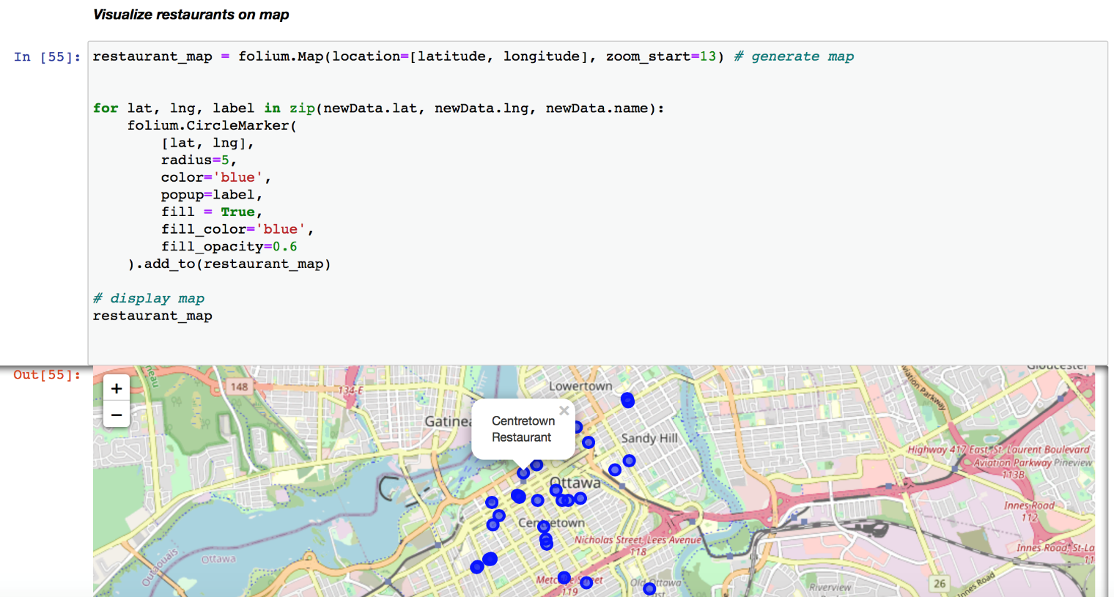

Now, let’s create clusters to group our restaurants by distance from the city center (which are closer, and which are further away). We’ll do it by removing irrelevant columns (of a non-numeric format), creating array of 3 clusters to sort our restaurants:

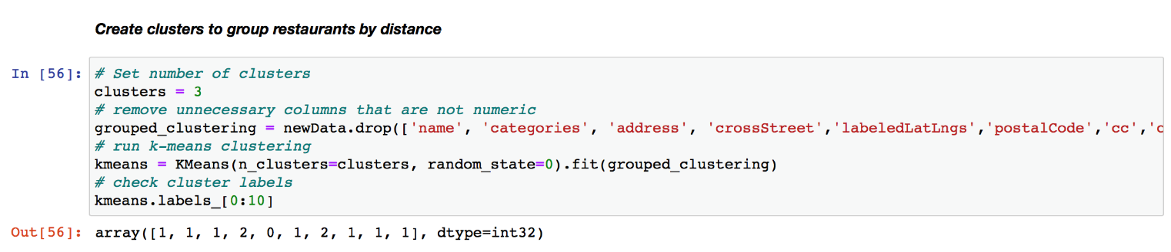

Now, let’s add our clusters to dataframe:

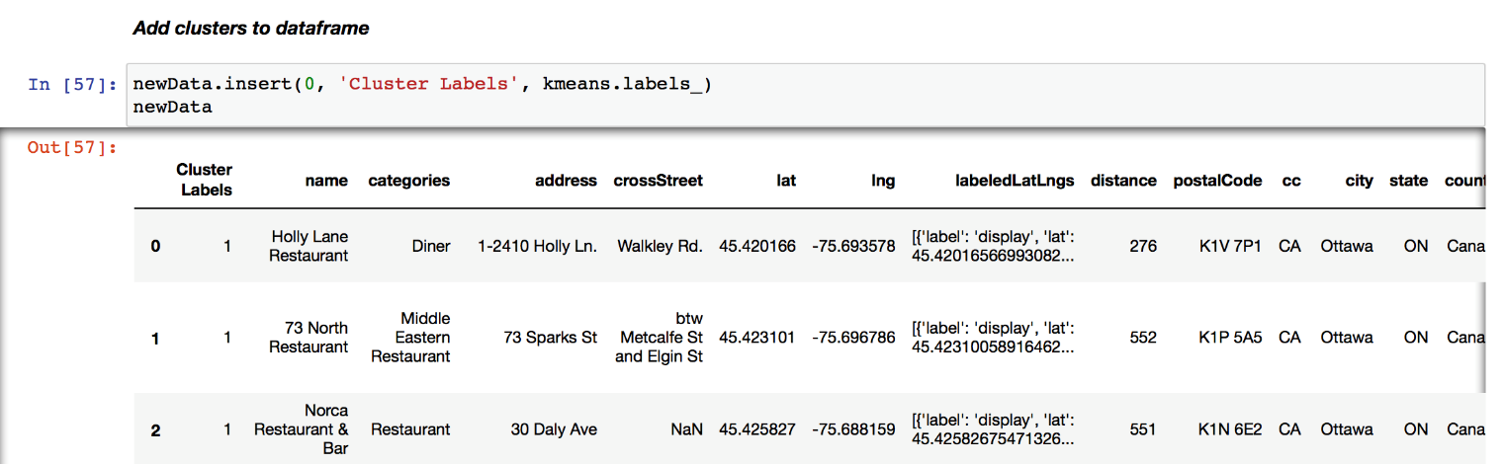

Next step is visualization of the results. Green dots are the closest to the center and purple ones are the furthest:

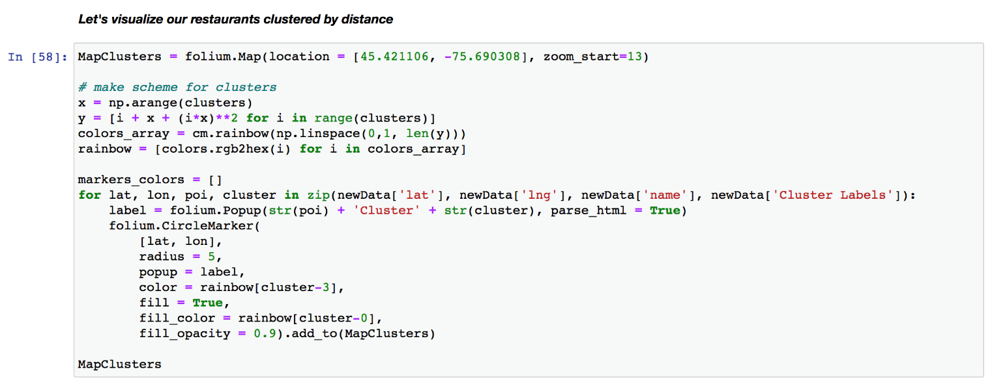

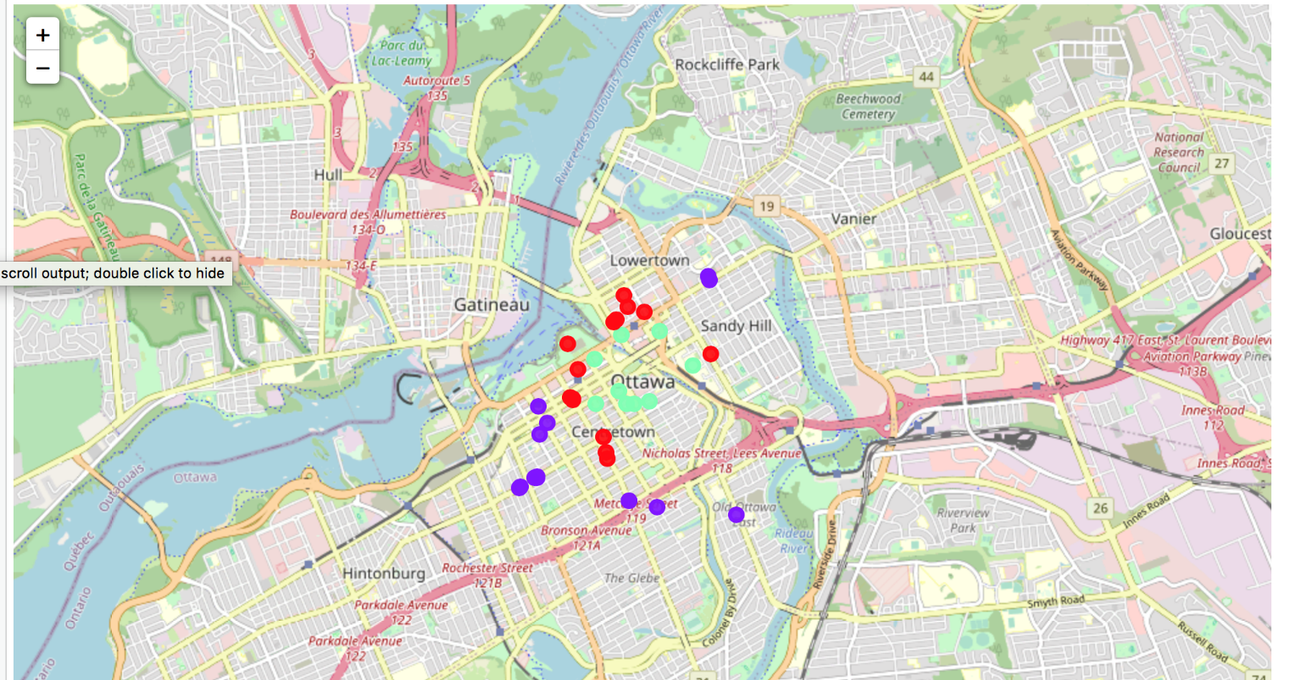

**Results**

Now, it’s time to summarize and discuss the results. First, we found there are about 30 schools of different type within 3km city center radius. Next, we visualized the house purchase price dynamics between 2000-2020 and can see that average house price grew from about CAD 100,000 to CAD 600,000. We also looked at the accommodation rental pricing trends in the last couple of years (2016-2020) for 1-, 2-, and 3- bedroom boarding. Rental costs were steadily growing until the start of pandemic when price of a 3-bedroom boarding has declined, price of 2-bedroom has remained at the same level and price of 1-bedroom rent kept growing overall. Next, we analyzed venues and recreational options available in downtown. We limited result to a list of 50 assuming going out once a week could be enough for our newcomer and displayed it on the map. Also, similar process was done to downtown restaurants with visualizing them on the map and clustering them based on distance.

**Discussion**

Will all the data we obtained and processed we can make several assumptions and conclusions. Haven’t heard of Ottawa as the most popular immigration destination (as opposed to hearing about Toronto and Vancouver), we can still see Canadian capital growing. For example, analyzing house price trends we can see that real estate market has grown 6 times in the past 20 years, successfully overcoming several world-wide financial crises. We could see from the bar chart above that there were only 2 instances of the average sale price dropping compared to previous year and once instance of staying the same. However, in the second year the price would make up for the loss of dynamics and grow quicker. When we look at 2019-2020, it’s obvious that despite the COVID-19 pandemic, average house prices in Ottawa remained the same and the market didn’t crash. These dynamics factors we can consider as favourable for our newcomers: in the beginning of 2021 they can still buy Ottawa property at 2019 prices and rest assured the invested money (down-payment, etc) won’t perish (as they haven’t within last 20 years). Another conclusion that we can make from the data we obtained, processed and analyzed is that the best option might be buying a 1-bedroom apartment/condo/townhouse. As we see from rental prices line graph, in the past couple of years bigger accommodations have dropped in price when 1-bedroom dropped but already resumed their growth. This means that such boarding might be more flexible, popular and less risky to own. Newcomers are usually young couples who would perfectly fit into 1-bedroom place. Sometimes, they have a young child; but it’s quite rare for them to be a family of 4 or more. Hence, small accommodation can be the most cost-effective solution for them in the first several years of their new life. Afterwards, once their family grows bigger or they decide to move another district/city/country, they would still end up being in a favourable situation – as we saw from the graph 1-bedroom accommodations are a good idea for investment since even after market collapse they regain previous price level quickly.

If our newcomers are looking to continue their education and obtain an additional certificate or diploma, or if they have a child who needs to attend school, Ottawa downtown is a nice spot to be with about 30 different options. Among those we saw several public schools, as well as language, sports, business and IT schools. There is even a driving school downtown.

When we look at venues and restaurants available in Ottawa, we see there’s a lot of them withing walking distance (had to limit our search to a list of 50). Different cuisines can satisfy every taste as well as any pocket. Downtown is also rich for other entertainment options: one can go skating on the famous Rideau Canal Skateway, visit Art Gallery, National War Memorial or enjoy numerous parks (what isn’t always an option in a metropolitan city).

**Conclusion**

Summarizing our neighbourhood exploration effort, data we used from several sources, and the results we saw on graphs, we can say that overall Ottawa downtown is a perspective place to settle for young immigrants. Ottawa has a very smart investment opportunity for 1-bedroom housing, its downtown is filled with a variety of educational, cultural and entertaining activities for any taste and demand.

Thank you!